X-Celeprint Acquires Next-generation Production Tool Capability for Heterogenous Integration using Micro-transfer Print (MTP) from X Display Company

X-Celeprint Ltd. (Cork, Ireland), today announces the acquisition of key manufacturing intellectual property (IP) and equipment assets from X Display Company Technology Ltd. (XDC), including the engineering and support team with the expertise to meet the demand for production capacity in Micro Transfer Print (MTP) for Silicon Photonics. X-Celeprint, the pioneer of Micro Transfer Printing (MTP) capability and the leading solution provider for super-heterogenous integration of semiconductor, photonics and optics materials and devices, is acquiring the MTP equipment operations of X-Display Inc. in a private transaction.
Commenting on the transaction, Peter Smyth, CEO of X-Celeprint said, “This acquisition adds manufacturing tool capability to X-Celeprint’s leading MTP solutions, meeting the stringent production performance requirements of Hyper-scaler, Datacom, High-performance Computing and Consumer applications markets. This integrated MTP platform enables us to overcome the extreme integration challenges of our industry partners and achieve high-yield, cost-effective volume production in the fastest-growing global markets.”
The XDC team’s proven experience deploying the world’s only production-grade MTP tool will combine with X-Celeprint’s advanced MTP platform for integrating small, fragile, and diverse materials, delivering sub-micron placement accuracy with exceptional yield and throughput (exceeding 200 million units per hour). This capability ensures 24/7 production reliability for semiconductor and photonics integration using MTP, at scalable cost and without compromising manufacturing precision or device performance.
Alex Chikhaoui, Business Development Director at X-Celeprint, believes that the timing of the acquisition is perfectly aligned with the accelerating momentum in Silicon Photonics. “Our industry partners are now entering a phase where scale-up and scale-out are no longer future considerations—they are immediate, pressing market requirements. Silicon Photonics is moving rapidly from early adoption into high-volume deployment, and the entire value chain is feeling the urgency to support dramatically higher throughput. The volumes expected over the next few years will be unprecedented, and only Micro-transfer Printing offers the combination of precision, speed, and manufacturing flexibility required to meet this demand. By acquiring this printer business now, X-Celeprint is adding the only production-grade MTP tool portfolio to its existing capability and is ensuring that our customers have access to the scalable, production-ready MTP capability needed to deliver the next generation of high-performance photonic devices.”

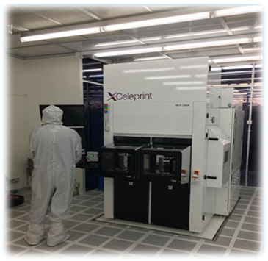

[ENDS]

About X-Celeprint
X-Celeprint is the pioneer of Micro Transfer Printing (MTP) capability and the leading solution provider for demanding heterogenous integration solutions using MTP in high-growth markets such as Datacom, High-performance Compute/AI, Datacentre/Storage and Consumer. With R&D and MTP printing centres in Europe and the US, the company delivers faster, smaller, higher performance, more energy efficient and environmentally friendly solutions in these high-growth markets. The company is privately held and headquartered in Cork, Ireland.
www.x-celeprint.com

